TROUBLESHOOTING AND HELPDESK

Assignment DAY3
TASK1: List 5 common BIOS or POST error messages you might see when starting a PC and write what hardware or configuration issue each one usually points to.

BIOS/POST Error Message | Hardware or Configuration Issue
CMOS Checksum Error – Defaults Loaded | CMOS battery is weak or BIOS settings have been reset.
Keyboard Error or No Keyboard Present | Keyboard is not connected or is faulty.
No Boot Device Found | Hard disk/SSD is not detected or has no operating system installed.
CPU Fan Error | CPU cooling fan is not connected or has failed.
Memory Error / RAM Failure | RAM is loose, faulty, or not detected by the motherboard.

TASK2: Given this scenario: On boot, a PC beeps 3 times in a repeating pattern and does not display anything on the screen. Research and write what this POST beep code typically means for an AMI BIOS, and suggest two troubleshooting steps.
For a traditional AMI BIOS, 3 short/repeating beeps typically indicate a base-memory failure, specifically an error while testing the first 64 KB of RAM. This usually points to a faulty, loose, or improperly seated RAM module. (forum-en.msi.com)
Two troubleshooting steps:
- Reseat the RAM: Turn off and unplug the PC, remove the RAM module, clean the contacts gently, and firmly reinstall it until the clips lock.
- Test the RAM: If there are multiple RAM sticks, test one stick at a time and try different RAM slots. If one stick causes the beeps while another works, the faulty RAM can be identified. (intel.com)

TASK3: Access the BIOS setup utility on any available PC or virtual machine, take a screenshot of the main BIOS screen, and identify the motherboard manufacturer and BIOS version.

BIOS SETUP PAGE:
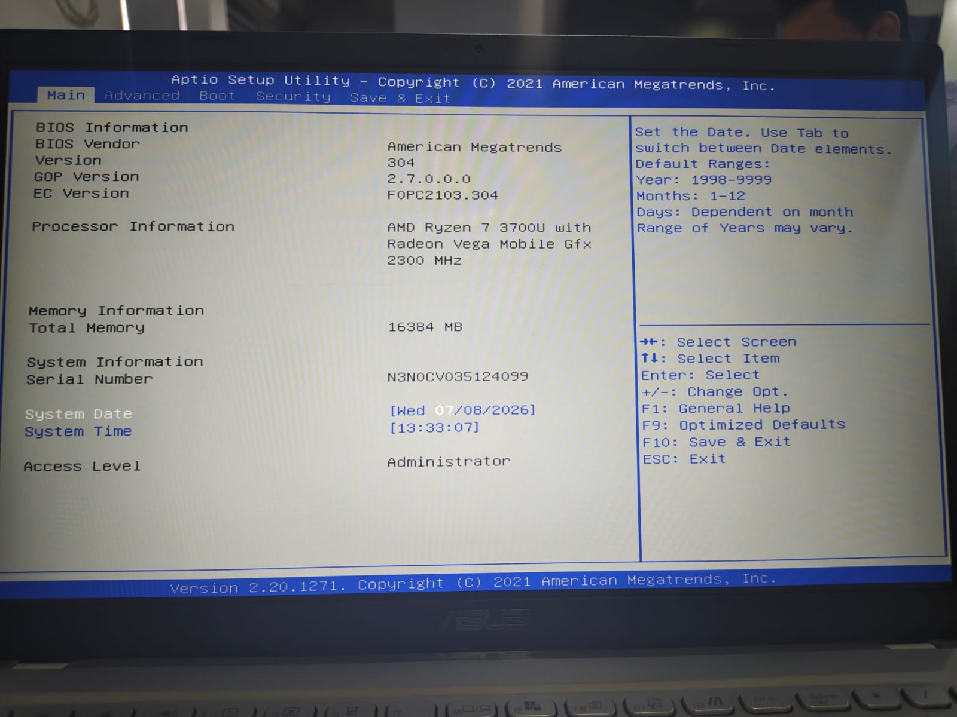

MOTHERBOARD MANUFACTURER:
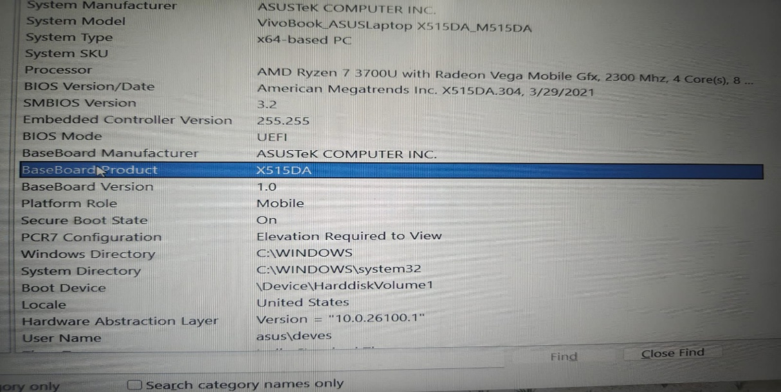

TASK4: You are given a screenshot of a POST error message that says 'CMOS checksum error – Defaults loaded.' Explain what this means and describe how you would resolve this issue in a real system.<br><br><em><strong>Hint:</strong> Think about the CMOS battery and BIOS settings reset.</em>

The message "CMOS Checksum Error – Defaults Loaded" means that the BIOS settings stored in CMOS memory have become invalid or were reset. This usually happens because the CMOS battery (CR2032) is weak or has been removed.
How to Resolve the Issue
- Turn off the computer.
- Open the computer case.
- Locate the CMOS battery on the motherboard.
- Replace the battery with a new CR2032 battery if necessary.
- Start the computer and enter the BIOS Setup.
- Set the correct date and time.
- Save the BIOS settings and restart the computer.

